GROUP 1 Civil Rights Actions in the 1940’s – 1950’s

Background: The fight for civil rights in the United States began before the Constitution was ratified. Our investigation today starts in the 1940s. Key civil rights leaders of that period used the threat of large-scale protest marches in the nation’s capital to pressure political leaders into addressing civil rights inequalities. In 1941, threats of marches led President Roosevelt to sign Executive Order 8802, and in 1947 a threatened march prompted President Truman to sign Executive order 9981.

Inquiry Compelling Question:
How was the 1963 March on Washington for Jobs and Freedom a defining moment for the civil rights movement in the United States?

Supporting Question(s):
1.___________________________________________________________________________

2.___________________________________________________________________________

3.___________________________________________________________________________

4.___________________________________________________________________________

CARD 1 Civil Rights Actions in the 1940’s – 1950’s

Background: A. Philip Randolph, a union organizer and rights activist, along with rights activists Bayard Rustin and A. J. Muste planned a non-violent mass march on the nation’s capital to press President Roosevelt for ending employment discrimination in factories producing war goods for the federal government.

March on Washington flier, 1941
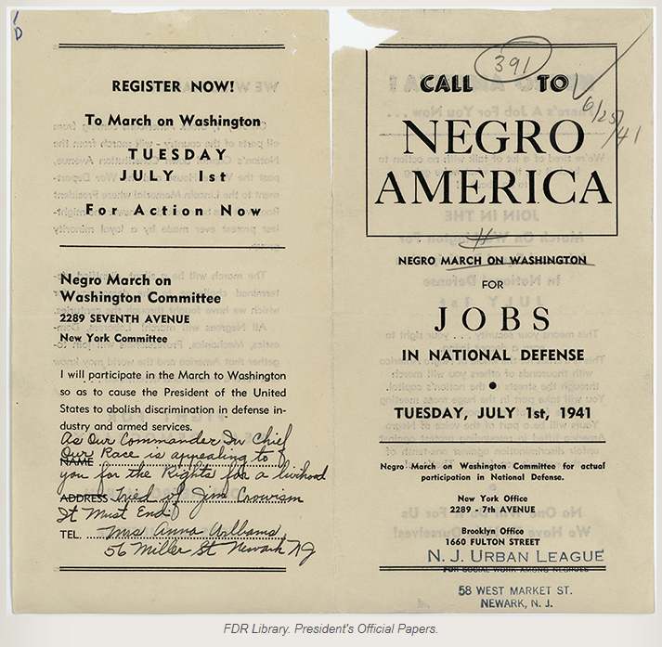
This flier, which A. Philip Randolph included with a letter he wrote to Eleanor Roosevelt announces a planned march on Washington, D.C. in July, 1941.
FDR Presidential Library: http://www.fdrlibrary.marist.edu/daybyday/resource/june-1941-9/
Consider:
1. What is the stated goal of the proposed march?
2. How does this document relate to the document on Card 2?

CARD 2 Civil Rights Actions in the 1940’s – 1950’s

"Executive Order No. 8802" Fair Employment Practice in Defense Industries
U.S. presidents have the authority to issue executive orders that direct government agencies (within the executive branch) to act or interpret regulations a certain way. Executive Orders can be reviewed by courts or overturned a with a law. Executive Order 8802 was signed by President Roosevelt in 1941.
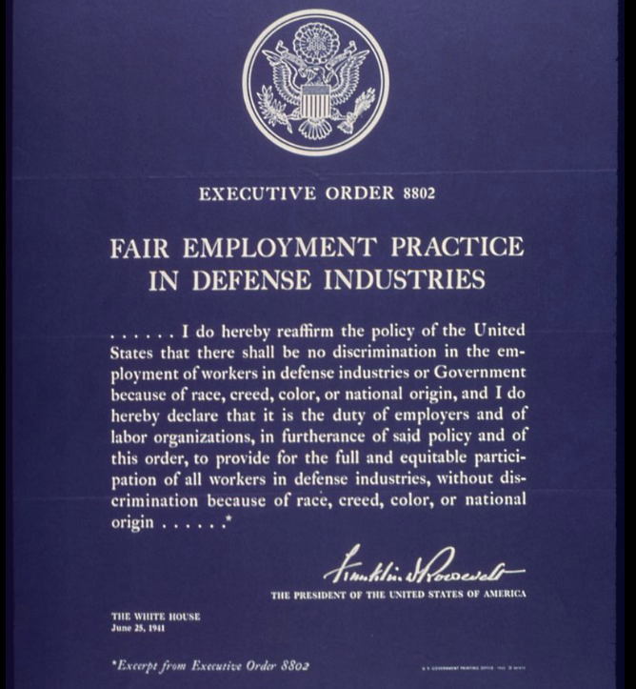
National Archives: https://catalog.archives.gov/id/514231
Consider:
1. Why is the date of the executive order significant when compared to the document on Card 1?
2. Why might the march organizers consider a march that didn’t take place a success?

CARD 3 Civil Rights Actions in the 1940’s – 1950’s

United We Win Poster – 1943
The War Manpower Commission was a federal commission that created strategies and media that would promote patriotism and the war effort to motivate American workers.
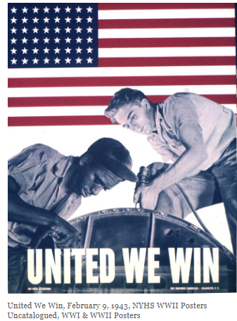
United We Win, February 9, 1943, NYHS WWII Posters, Printed by the Government Printing Office for the War Manpower Commission, National Archives

Consider:
- What is the civil rights message of the poster?
- What does the need for a promotional poster to push that message two years after an executive order was issued reveal about the implementation of the order?

CARD 4 Civil Rights Actions in the 1940’s – 1950’s

Newspaper Headline: By Executive Order--President Truman Wipes Out Segregation in Armed Forces, Chicago Defender, July 31, 1948.
President Truman reacted to a proposed march and the formation of the League for Non-Violent Civil Disobedience Against Military Segregation, led by A. Philip Randolph and Grant Reynolds by signing Executive order 9981. Some branches of the military began to desegregate quickly while others did not become fully desegregated until more than a decade later.

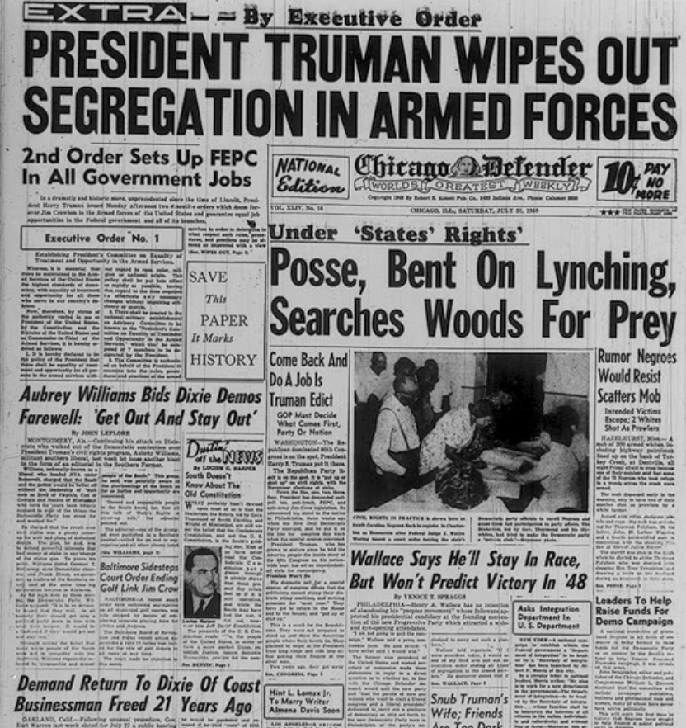
Library of Congress: https://www.loc.gov/exhibits/odyssey/archive/09/0902001r.jpg
Consider:
- Why might A. Philip Randolph consider a strategy of a march after his experiences in 1941 (Card 2)?
- How do the placement and language of the headline about Executive Order 9981 suggest the newspaper editors felt about the order’s impact?
- What might a person skimming the front-page headlines of this paper conclude about progress being made towards civil rights equality?

CARD 5 Civil Rights Actions in the 1940’s – 1950’s

A Civil Rights Time Line 1940-1960

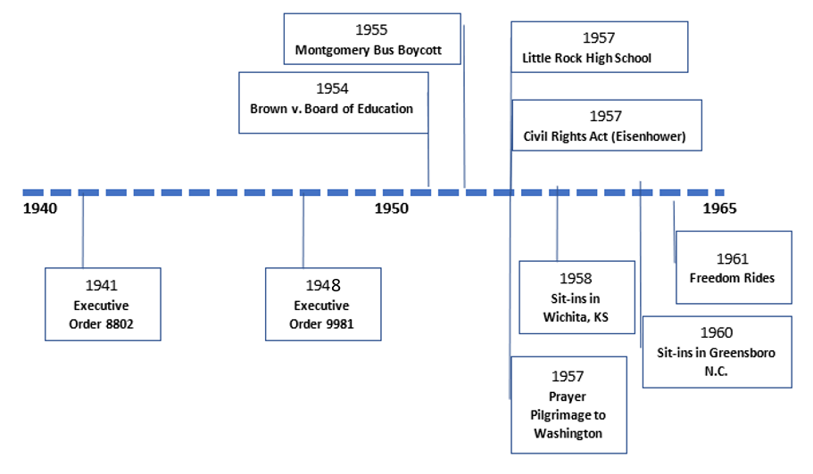

- 1941: Executive Order 8802 (Fair Employment Act) required desegregation in industries producing war materiel and set up a federal agency to monitor progress, the Fair Employment Labor Commission.
- 1948: Executive Order 9981 – ordered the desegregation of all branches of the military. It took nearly 15 years to achieve the goal.
- 1954: Brown v. Board of Education of Topeka, KS – Supreme Court ruling ordering schools to desegregate.
- 1955: Montgomery Bus Boycott – a successful boycott of public transportation in Montgomery ended when the Supreme Court ruled segregation on public transportation was illegal.
- 1957: Prayer Pilgrimage to Washington – A. Philip Randolph and Bayard Rustin organize a march to recognize the third anniversary of Brown v. Board decision and the lack of action in integrating schools. Dr. King’s speech helped launch him on a national stage.
- 1957: Civil Rights Act – had limited impact in protecting voting rights but created federal agencies to protect civil rights.
- 1957: Little Rock High School – President Eisenhower federalized the Arkansas National Guard to enforce desegregation at Little Rock High School.
- 1957-1961: A series of direct-action events, including marches, sit-ins, and Freedom Rides (riders challenged segregation on buses in the South) brought attention but limited gains.
Consider:
- Which of the events listed would might feel like civil rights successes in that period? Which would not?
- How might a person in 1961 describe the progress towards civil rights equality in the period 1940-1961?
- Why might the pace of change shown and the need to mobilize across large geographic areas encourage civil rights leaders to call for a civil rights bill that would address all parts of civil rights nationally.

GROUP 2 Planning the 1963 March on Washington

Background: Not all civil rights leaders and groups favored the same approaches to achieve civil rights goals. Some preferred direct action and civil disobedience to jolt the public consciousness and achieve change over time. Others preferred to work “inside the system” to win battles in courts and pass new legislation over time. A few favored more radical approaches to force change to take place quickly. To reach a consensus on event goals, leaders agreed the speeches would avoid criticizing the Kennedy Administration and the march had to be peaceful.

Inquiry Compelling Question:
How was the 1963 March on Washington for Jobs and Freedom a defining moment for the civil rights movement in the United States?

Supporting Question(s):
1.___________________________________________________________________________

2.___________________________________________________________________________

3.___________________________________________________________________________

4.___________________________________________________________________________

CARD 6 Planning the 1963 March on Washington

Planning the March on Washington for Jobs and Freedom
In 1962, union organizer and political activist A. Philip Randolph and longtime civil rights organizer Bayard Rustin called for a march on Washington to promote economic opportunities for African Americans. Randolph then invited key civil rights leaders to join the effort in 1963. The “Big Six” civil rights leaders met with president Kennedy at the White House to discuss the march plans.
Key march organizers (border indicates the initial planning group)
Initial organizers

Invited
later

Person | Role or Organization
A. Philip Randolph | March on Washington Director (and head of NALC: Negro American Labor Council)
Roy Wilkins | NAACP: National Association for the Advancement of Colored People
Dr. Martin Luther King, Jr. | SCLC: Southern Christian Leadership Conference
Whitney Young | NUL: National Urban League
James Farmer | CORE: Congress on Racial Equality
John Lewis | SNCC: Student Non-Violent Coordinating Committee
Dorothy Height | NCNW- National Council of Negro Women
Bayard Rustin | March on Washington Deputy Director
Joachim Prinz | AJC: American Jewish Congress
Mathew Ahman | NCCIJ: National Catholic Conference for Interracial Justice
Eugene Carson Blake | NCC - National Council of Churches
Walter Reuther | UAW – United Auto Workers

The “Big Six” Civil Rights Leaders
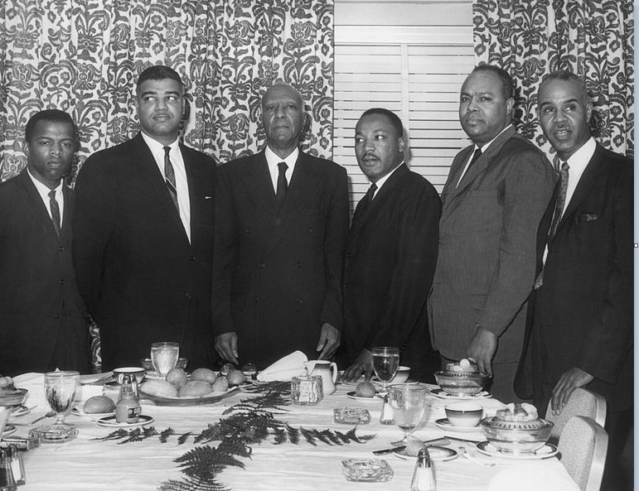
The "Big Six" Civil Rights Leaders (l to r) John Lewis, Whitney Young Jr., A. Philip Randolph,
Dr. Martin Luther King, Jr., James Farmer Jr., and Roy Wilkins.
Hulton Archive/Getty Images

James Farmer was later quoted as saying that Dorothy Height should have been considered one of the “Big Six” leaders.

Consider:
- Why might it be significant that Dorothy Height was not considered to be one of the Big Six leaders who visited with President Kennedy?
- How could the inclusion of the “invited later” groups extend the support for the March on Washington for Jobs and Freedom?

CARD 7 Planning the 1963 March on Washington

Cooperation Despite Competing Goals and Strategies
Civil Rights organizations had a common goal to win civil rights gains but had different approaches and areas of focus. Some focused on winning economic opportunities (jobs) while others focused on voting and other rights. Uniting for the 1963 March on Washington proved a challenge but groups agreed list of 10 goals or demands.
Favored negotiation and legal actions to win new legislation  - NAACP  - NCNW  - NUL--------->  (shifted later) | Favored education efforts, direct-action and civil disobedience events  - SCLC  - CORE  - SNCC ------>  (shifted later) | Favored more “radical” positions and approaches  - Nation of Islam  - Malcolm X  - Stokely Carmichael

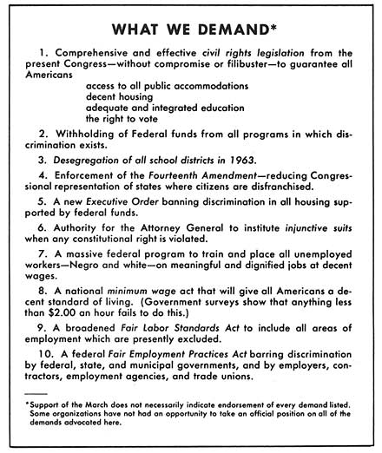
Cooperation Among Groups
Council for United Civil Rights Leadership- At about the same time as the planning for the 1963 march began, the “Big Six” civil rights organization agreed to form a council to coordinate fundraising and distribution of funds for civil rights activities. Stephen Currier, head of the main fundraising organization, was the only white member of the council leadership.

Final List of Goals (or Demands) of the 1963 March on Washington for Jobs and Freedom
Originally called the October Emancipation March on Washington for Jobs by A. Philip Randolph, the larger planning committee decided to change it to the march on Washington for Jobs and Freedom to include various goals by the organizers.

Consider:
- How could cooperation among the groups change the impact of the civil rights movement?
- What evidence on cards 6 and 7 suggest disagreements remained among groups and civil rights leaders despite cooperation on the 1963 march?
- How did the name of the march and the evidence on the What We Demand pamphlet illustrate an attempt to honor the different goals and approaches of the groups involved?

CARD 8 Planning the 1963 March on Washington

Opposition to the March
Malcolm X was a leader in the Nation of Islam during this period, rejecting Dr. King’s non-violence approach to incremental change, instead advocating Black Nationalism. He later called for “freedom by any means necessary.”
Anxious about the possibility that violence might break out on the day of the march, the Kennedy administration had pressed organizers to permit only preapproved signs and to tamp down attendance by holding the event on a weekday rather than a Saturday.

Some black groups, fearing a public relations debacle, endorsed such limits. The NAACP made its support contingent on getting the crowd in and out of town in a matter of hours. Rustin, the chief organizer, agreed that it was imperative that the march be perceived as a mix of blacks and whites and avoid the “crackpotishness” of sit-ins, fasts and other more confrontational protests that had emerged around the nation.

“Unless we got white people into the street with Negroes for the march, the fight would appear to be between white people and black and not between justice and injustice,” he told The Post.

But other black groups, pushing for more direct action against segregation, said Rustin was caving to the white establishment. Leaders such as Stokely Carmichael boycotted the march; Malcolm X dubbed it the “Farce on Washington.”

“The white man” put his handpicked black leaders in charge of the march, Malcolm X told supporters later. “They took it over. And they invited a priest, a rabbi, and an old white preacher. Yes, an old white preacher. It’s just like when you’ve got some coffee that’s too black, which means it’s too strong. What you do? You integrate it with cream; you make it weak.”
Washington Post: https://www.washingtonpost.com/sf/local/2013/08/22/
there-was-this-fear/?utm_term=.a7e3a9f526bc
“Let's form this council [Council for United Civil Rights Leadership], and all the civil-rights organizations will belong to it, and we'll use it for fund-raising purposes. Let me show you how tricky the white man is. And as soon as they got it formed, they elected Whitney Young as the chairman, and who [do] you think became the co-chairman? Stephen Currier, the white man, a millionaire.“
Malcolm X, "Message to the Grass Roots", speech given 10 November 1963 in Detroit, Michigan.
Wikipedia, “Council for United Civil Rights Leadership”, September 2019.
Stokely Carmichael was involved with SNCC from the direct-action campaigns of sit-ins and Freedom Rides of the early 1960s, later the Chairman of SNCC. He transitioned from nonviolence to a call for Black Power and became a leader in the Black Panthers in the late 1960s. Carmichael boycotted the 1963 march.
“Stokely Carmichael of SNCC said it was ‘only a sanitized, middle-class version of the real black movement.’ “
Heroes & Villains, National Archives: https://www.nationalarchives.gov.uk/education/heroesvillains/g6/cs3/
Consider:
- Why wouldn’t the march organizers attempt to include Malcolm X and Stokely Carmichael on the march planning committee?
- How do the reactions of Malcolm X and Stokely Carmichael represent a growing split in the civil rights movement at a time the Big Six were starting to work together?

CARD 9 Planning the 1963 March on Washington

The Kennedy Administration – President John F. Kennedy received more than 70% of the African American vote in the 1960 election was inspired to act on civil rights legislation after violence against civil rights activists during the Freedom Rides on 1961 and Birmingham demonstrations of 1963, as well as attempts to deny the integration of Ole Miss and the University of Alabama. Once he introduced the bill, he knew he needed the support of Southern legislators and was reluctant to do anything that would jeopardize their votes. Once civil rights leaders made it clear the march would go forward, his administration offered assistance to ensure a peaceful event, but also pushed organizers to get marchers out of town by the end of the day.

John Lewis recalled the June 22 meeting between the March on Washington organizers and President Kennedy:
"It was a very moving meeting," Lewis said. "The president was deeply concerned about what was happening in the American South. So the president wanted to know what could be done."
Then A. Philip Randolph, the elderly labor leader revered by many in the civil rights movement, announced to the president that there would be a march on Washington.
"You can tell by the very body language of President Kennedy ... he started moving and twisting in his chair. And his facial expression -- he just thought it would be chaos," recalled Lewis.
"And the president sort of said, 'Well, I think we're gonna have some problems.”
CNN.com, August 28, 2013: https://www.cnn.com/2013/08/28/politics/march-on-washington-kennedy-jitters/index.html
A 2003 article by the British paper, The Guardian, recounts an exchange between President Kennedy and Dr. Martin Luther king at the meeting on June 22nd.
"We want success in Congress," said Kennedy. "Not just a big show at the Capitol." Randolph refused. "The negroes are already in the streets," he told Kennedy.
King, who deferred in age and experience to Randolph did not speak until the end of the meeting. "It may seem ill-timed," he said. "Frankly, I have never engaged in a direct-action movement that did not seem ill-timed."
The Guardian August 20, 2003: https://www.theguardian.com/world/2003/aug/21/usa.comment

In a 1979 interview, John Lewis recalls one Kennedy Administration strategy to “preserve peace.”
“And when the Kennedy Administration became so cooperative, when the, the people within the government became so helpful in providing logistic—the only thing they wanted, they wanted people
to come in to Washington and to get out before sundown. They wanted all of the black folks out of Washington before sundown and that's what—exactly what happened.”
Washington University in St. Louis: http://repository.wustl.edu/concern/videos/vt150m28q
Consider:
- What concerns did President Kennedy have about a mass demonstration in Washington?
- Why might President Kennedy offer assistance to ensure a peaceful march?

GROUP 3 August, 1963: Voices Heard / Voices Missing

Background: The day of the march found over 200,000 people marching the streets of Washington, D.C. The main program at the Lincoln Memorial included remarks by march organizers, civil rights speakers, and musical selections. But important voices were also excluded from the program. The evidence on your cards will help you investigate the significance of decisions about which voices to include in the program.

Inquiry Compelling Question:
How was the 1963 March on Washington for Jobs and Freedom a defining moment for the civil rights movement in the United States?

Supporting Question(s):
1.___________________________________________________________________________

2.___________________________________________________________________________

3.___________________________________________________________________________

4.___________________________________________________________________________

Card 11 August, 1963: Voices Heard / Voices Missing

A remembrance by Martin Luther King’s draft speechwriter Clarence B. Jones recalled "the lightning in a bottle" of Dr. Martin Luther King’s “I Have a Dream” speech.
He’s reading this text. He’s reading this at the podium. He’s over here and [this woman] turns to him and shouts to him, interrupts him. “Tell them about the dream Martin. Tell them about the dream.” And he pauses. I look at him and take the text. He moves it off to the side and grabs the podium. I turn to the person standing next to me. This is all happening in real time. And I say: “Look at these people. They don’t know it, but they’re about ready to go to church.” Because I can tell by Dr. King’s body language, that where he stood implacably reading the text, that his body language has changed to this preacher mode.

That’s when he started speaking, I have a dream. That was totally spontaneous, totally extemporaneous. If you listen to the speech, I say that Martin King had a much more prophetic confidence in America than America had in itself. Because the speech where he uses I have a dream is all in the future tense. “I believe that one day…. I believe that one day my poor children will be judged by the content of their character and not by the color of their skin. I believe that one day the great, great grandsons of slaves and the great, great grandsons of slave owners will sit down at the table of brotherhood….” All in the future tense — paragraphs that you read, all in the future tense. The most extraordinary thing I had ever seen.
Remembering 'I Have a Dream', Brennan Center for Justice, August 28, 2013
https://www.brennancenter.org/our-work/analysis-opinion/remembering-i-have-dream

News coverage of the August 28, 1963 March on Washington

“CBS spent a good deal of its early afternoon coverage by talking to politicians about the impact of the March. Several senators thought that the March would have a deleterious effect on race relations. CBS missed several important highlights of the ceremony, including the short tribute to the women of civil rights. But the major speeches of the participating groups were interpreted with some commentary. Roger Mudd, who was the anchor for CBS News, noted that the rhetoric of the youngest speaker, John Lewis of SNCC, was toned down from his original vision. He dispassionately opined that Dr. King's speech moved the crowd to a standing ovation, with nothing on the substance. But that was more than the Washington Post's lead story, which concentrated on the orderliness of the crowd, never mentioning Dr. King at all.”

Paley Center on the Media: https://www.paleycenter.org/p-march-on-washington

Consider:
- What was remarkable about Dr. King’s speech?
- What is significant about the news coverage of the speech and event?
- What factors may have played a role in the way the speech and event were covered?

Card 12 August, 1963: Voices Heard / Voices Missing

John Lewis’s Speech
1) Interview with John Lewis conducted for America, They Loved You Madly, a precursor to the epic documentary of the civil rights movement, Eyes on the Prize.

INTERVIEWER 1:] WHO—WHOSE—WHO WAS BEHIND THE MOVEMENT TO CHANGE YOUR SPEECH?

[John Lewis:] Well, from, from the outset it was, it was strange the way that happened and to this day I don't know all what went to make that possible. We had, and when I say “we” I would say the representative of the Student Nonviolent Coordinating Committee, had assisted me in preparing what I thought was a very simple, very elementary statement for the March on Washington. Julian Bond was then the communication director of SNCC, had to make copies of the speech available in advance. The Tuesday night before the march, we all were staying at a hotel in Washington DC, and that night I was in my hotel room. I got a call from Bayard Rustin who suggested that there was some problem with my speech and there would be a meeting to discuss the speech and other arrangements for the March on Washington and I should come down for the meeting. And at this meeting, there was representatives from SCLC, the NAACP, all of the organization, the Catholic Church, everybody. And we really argued about, about the speech.
Washington University, St. Louis: http://repository.wustl.edu/concern/videos/vt150m28q
2) Two Versions of John Lewis’ Speech
This excerpt is an introduction to the Bill Moyers program “John Lewis Marches On.”
“As the head of the Student Nonviolent Coordinating Committee, John Lewis drafted a fiery speech to present to the crowds gathered at the March on Washington. But the night before the storied march, the speech was mistakenly leaked to the press, and as word of its contents began to spread, Lewis was summoned to a meeting with the march’s leaders and urged to tone down certain elements. Out of respect for leaders like A. Philip Randolph and Dr. Martin Luther King, Lewis edited his harsh criticism of the Kennedy administration’s civil rights bill, which he’d originally called “too little and too late,” and changed his call for a march “through the heart of Dixie, the way Sherman did” to a march “with the spirit of love and with the spirit of dignity that we have shown here today.”
Moyers and Company ( Bill Moyers website): https://billmoyers.com/content/two-versions-of-john-lewis-speech/

Consider:
- What is significant about John Lewis changing his speech?
- How might the pressure to change the speech reflect disagreements or tensions within the coalition of civil rights groups?
- How does the edited speech reflect a “voice not heard?”

Card 13 August, 1963: Voices Heard / Voices Missing

Women’s Voices at the 1963 March on Washington for Jobs and Freedom
1) The Women Behind the Men, Gail Collins [Editorialist], September 2007
“Daisy Bates had to march with the wives.
When the nation observes the 50th anniversary of the Little Rock school desegregation on Monday, there will undoubtedly be a great deal said about Bates, who was head of the city’s N.A.A.C.P. chapter. She helped recruit nine black teenagers and escorted them through irate mobs of white adults and into their first classes. As a result, she and her husband, Lucius, lost their business. She was jailed, threatened and the Ku Klux Klan burned an 8-foot cross on her lawn.
Bates was invited, of course, to the famous March on Washington in 1963, when Dr. Martin Luther King Jr. gave his “I Have a Dream” speech. Rosa Parks was invited, too, and Pauli Murray, the lawyer and feminist who had staged the first sit-in at a Washington restaurant during World War II.
When they got there, they were all assigned to walk with the wives of the male civil rights leaders, far away from the cameras. “Not a single woman was invited to make one of the major speeches or be part of the delegation of leaders who went to the White House. The omission was deliberate,” Murray said later.
Dorothy Height, the head of the National Council of Negro Women, and others begged that at least one woman be included among the speakers. They nominated Diane Nash, the student leader who had been perhaps the one person most responsible for the success of the Freedom Riders in the South. No dice.
“Nothing that women said or did broke the impasse blocking their participation. I’ve never seen a more unmovable force,” Height wrote. The men kept telling her that women already had participation — both Marian Anderson and Mahalia Jackson were going to sing. In the end, A. Philip Randolph delivered a “Tribute to Negro Women Fighters for Freedom” while the female civil rights legends sat on the stage...”
New York Times opinion/Editorial Page: https://www.nytimes.com/2007/09/22/opinion/22collins.html

2) A speech by Pauli Murray (civil rights veteran) delivered at the National Council of Negro Women in Washington, DC in November, 1963.
Negro women, historically, have carried the dual burden of Jim Crow and Jane Crow. They have not always carried it graciously but they have carried it effectively...
Recent disquieting events have made imperative an assessment of the role of the Negro woman in the quest for equality. The civil rights revolt, like many social upheavals, has released powerful pent-up emotions, cross currents, rivalries and hostilities... There is much jockeying for position as ambitious men push and elbow that way to leadership roles... What emerges most clearly from events of the past several months is the tendency to assign women to a secondary, ornamental or "honoree" role instead of the partnership role in the civil rights movement which they have earned by their courage, intelligence, and dedication. It was bitterly humiliating for Negro women on August 28 to see themselves accorded little more than token recognition in the historic March on Washington. Not a single woman was invited to make one of the major speeches or to be part of the delegation of leaders who went to the White House. This omission was deliberate. Representations for recognition of women were made to the policy-making body sufficiently in advance of the August 28 arrangements to have permitted the necessary adjustments of the program. What the Negro women leaders were told is revealing: that no representation was given to them because they would not be able to agree on a delegate. How familiar was this excuse! It is a typical response from an entrenched power group...
The path ahead will not be easy; the challenges to meet new standards of achievement in the search for equality will be many and bewildering. For a time, even, the casualties of integration may be great…As Lorraine Hansberry, the gifted playwright, has said, "For above all, in behalf of an ailing world which sorely needs our defiance, may we, as Negroes or women, never accept the notion of — ‘our place.’"
Source: Pauli Murray, “The Negro Woman in the Quest for Equality,” speech to the National Council of Negro Women Convention, Washington, D.C., 14 November 1963,
Accessed: https://cpb-us-e1.wpmucdn.com/blogs.uoregon.edu/dist/7/11428/files/2017/
03/Murray-The-Negro-Woman-2clsq0g.pdf

Consider:
- To what extent do the two readings corroborate each other?
- How is the exclusion of women’s voices in the main program described?
- In what ways is Pauli Murray’s speech reflect tensions within the civil rights movement and hint at potential fractures in the movement?

Card 14 August, 1963: Voices Heard / Voices Missing

Page from the program for the main event at the Lincoln Memorial, August 28, 1963

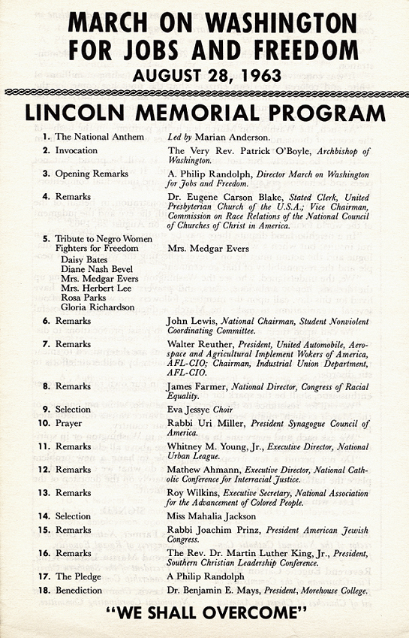

1. Marian Anderson was a famous operatic singer.

5. Mrs. Medgar (Myrlie) Evers was the wife of slain civil rights activist. She could not attend, so Daisy Bates delivered the brief remarks prepared by the march leaders.

9. Eva Jesse was a famed choral conductor

14. Mahalia Jackson was a famous gospel singer. She sang two inspirational songs.

Consider:
- How does the program reflect a strong religious element to the civil rights event?
- In what ways were women included in the main program?
- How might the role of women in the program reflect the views about women by the march planners?

